PFC - Assignment 2
Income tax bill and summary report with Files

As your second and final assignment this semester, you are to amend your program to store and manage personal tax data on file.

Learning Outcome
Upon successful completion of this assignment, you will have demonstrated the ability to use one-dimensional array data structures and sequential files (text or binary file).

Specifications
On running, your program displays the menu as belows:
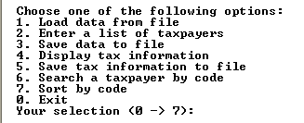
In the previous assignment we consider only personal tax information for one person. In this one you should use array to store data for taxpayers in a company. Two more data items are added to personal tax information: code and name.
You can select the option 2. to enter data for taxpayers. Beside keeping data validation as before, your program should check the entered code to be sure that it does not exists in the list.
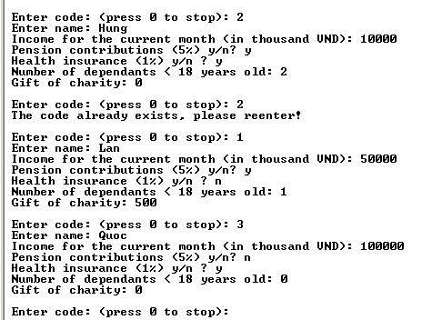
When you select the option 4., the program displays summary report like the following.
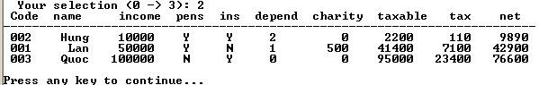

If you select the option 6 you can search a taxpayer by code:

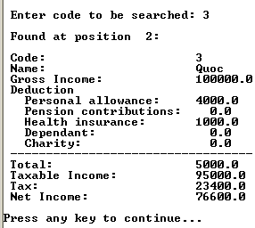
You can select 1. to load data from file, 5. to save data to file.
You can run the taxCalculator2.exe to see how your program should work.

Submission Requirements
At the beginning of your program, include comments reflecting accurate information for you in the format as below:

/*
Assignment 1 - Income tax
Class ID : SE0412
Student ID : 00400
Student Name : Nguyễn Minh Đức
Due Date : 30 September 2009
I declare that this assignment is my own work
in accordance with FPT Policy.
*/

